Thermal Pad Dimensions
RTX 3090 VENTUS 3X 24G OC
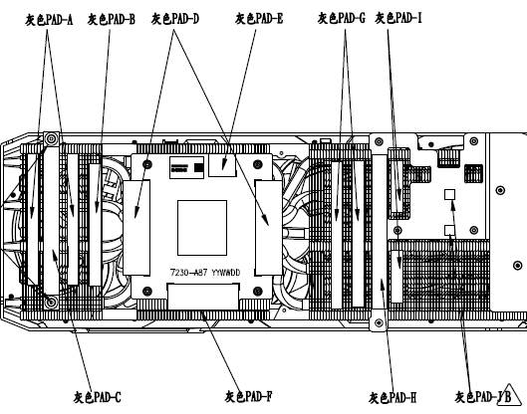
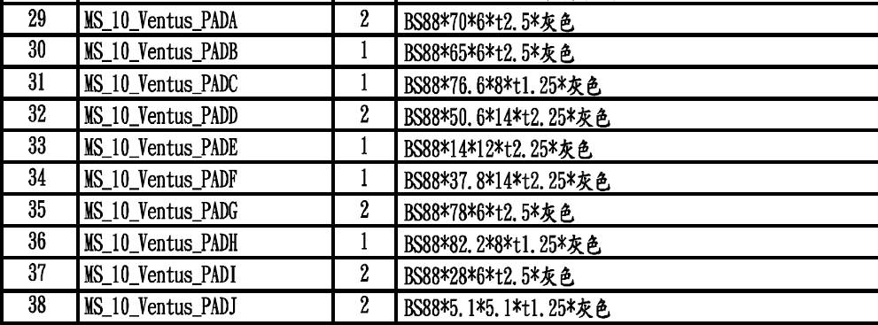

Anti-bending
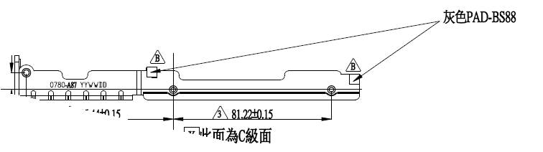

backplate
