Thermal Pad Dimensions
GeForce GTX 1650 GAMING 4G
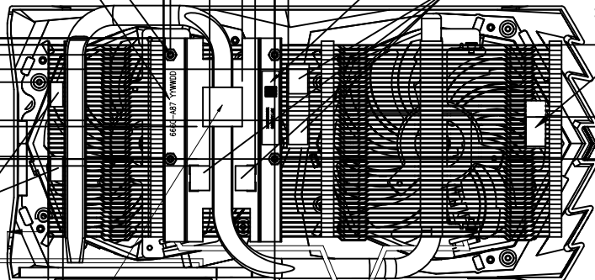
16
16
15
15
