Thermal Pad Dimensions
GeForce RTX 3080 Ti SUPRIM X 12G
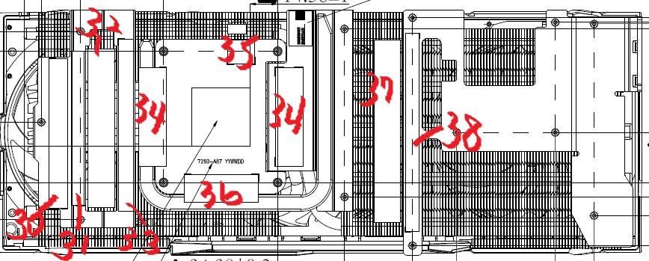
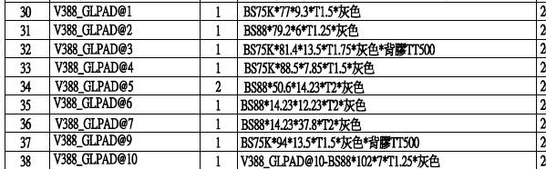

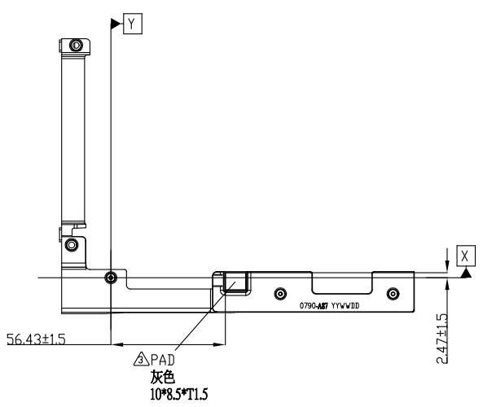

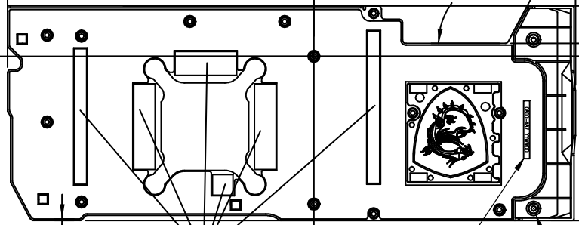
B
B
G
C
A
H
